**Modelling Forest Fires Worksheet Solutions**

**Worksheet 1: Spreading Dye/Game of Life**

### Spreading Dye

The black squares are stained with a dye. Empty cells (squares) which have **three or more** dyed neighbours become dyed. Cells which become dyed stay dyed. The dye spreads in time-steps, with all changes happening **once per time-step**. Model the spread of the dye on the diagram below. *It is easiest to use a new colour/pattern for each time-step so that you can mark the spread of the dye as you go along.*

For **each** time-step:

* 1. Choose a new colour.
  2. Work out which cells have any dyed neighbours. Mark these with a dot.
  3. For each dotted cell, work out whether it will become dyed – it must have 3 or more neighbours that became dyed **before this time-step**. If yes, colour in the cell.

Top tip: don’t forget the diagonals, and make sure you are not counting cells dyed in this time-step (i.e. coloured in using your current colour).

* 1. Once you have worked out all the cells which will become dyed it is the end of the current time-step. The cells you have just coloured in are now classed as dyed.

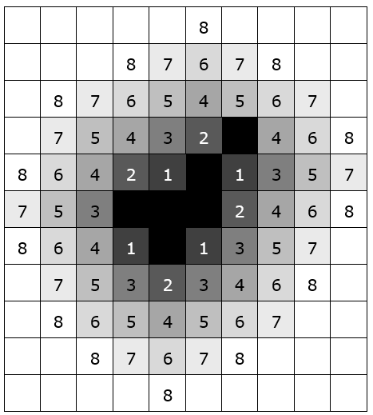



### Counting Neighbours

The initial set-up looks like this:

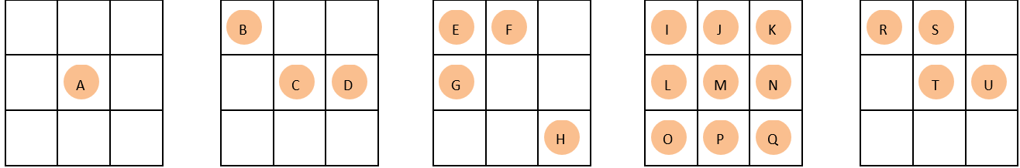

**1.** How many neighbours does each counter have? Fill in the table below.



* 1. In the above arrangements, which live cells will die from loneliness? ___A, B, D & H___
  2. Which live cells will die from overcrowding? ___ J, L, M, N & P____
  3. Which live cells will stay alive? ____C, E, F, G, I, K, O, Q, R, S, T & U____

*Now look at the* ***empty*** *squares. These have been given letters; the live cells are dotted.*

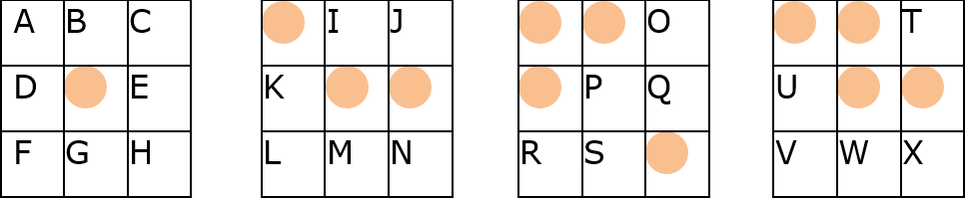

**5.** How many neighbouring live cells does each empty cell have? Fill in the table below:



**6.** Where will there be a new birth? ____ I, T & U ____

## Notes: Worksheets 2 & 3

There are no ‘answers’ to these, as what the students do will depend on the dice rolls. However, make sure they are rolling the dice once for **every** burning neighbour a tree has, and that if a tree did not catch light on the first go round, make sure they **check it again** on the next time-step (and so on).

For worksheet 3, make sure they are putting together some simple instructions which could be followed by someone else (or even a computer). These are the basics of programming.