**Maths of Voting: Worksheet Solutions**

**Worksheet 1: Can you gerrymander?**

Each map below represents a geographical area and the make-up of Blue and Magenta supporters within it, with each square representing a voter.

Can you divide each map into 6 continuous constituencies with 6 squares each so that the Magenta party wins overall, that is, it has the majority in the most constituencies?

There are different ways students can draw the constituencies for Maps 1 and 2 such that Magenta wins. Any solution that results in six groups of 6 voters, where at least four of them contain four Magenta voters, will be correct.

For example:

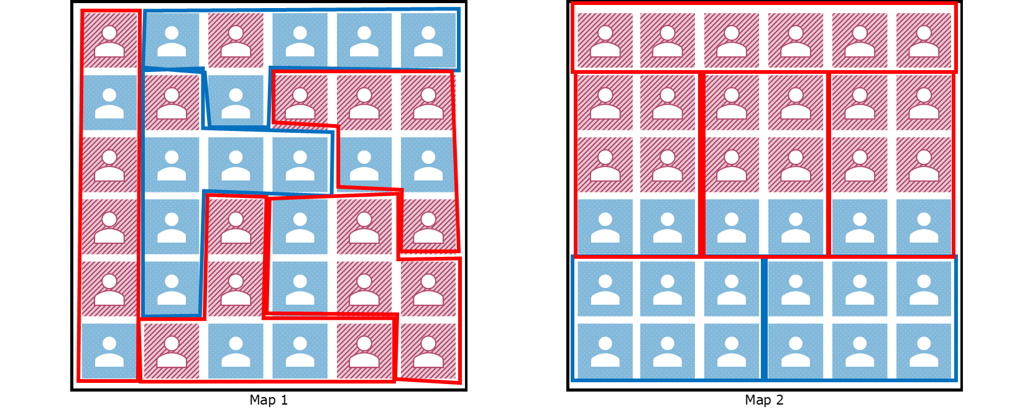

It is impossible for Magenta to get a majority in Map 3. You need at least 4 Magenta voters to make a Magenta winning constituency, and Magenta needs to win four constituencies overall to have a majority. This means that Magenta needs a minimum of 16 Magenta voters overall (4 voters x 4 constituencies = 16 voters) but there are only 14 Magenta voters in the area, so a majority cannot be reached.

Extension question:

**Imagine you’re a campaign manager hoping to turn Blue voters into Magenta supporters. Looking at the map below, what is the minimum number of voters that would need to vote Magenta for it to win overall?**

As we’ve seen with Map 3, the Magenta party needs at least 16 voters overall to have a majority. In the map below, it only has 12 voters. This means that the minimum number of Blue voters that would need to be turned is 4. There are multiple solutions that students can find to which 4 voters could be turned.

**Worksheet 2: Alternative Vote**

Instead of just putting down their favourite pizzas (or their first preferences), each family member has ranked their preferences, based on the four toppings available. You can see these rankings below.

Start by determining what is the majority in this example.

Then consider only the 1st preferences row. Do any of the toppings obtain a majority of votes? If yes, that is the winner. If no pizza topping obtains a majority, you need to eliminate the topping with the least number of votes and redistribute their votes. You keep doing this until one of the pizzas has a majority.

Which pizza topping is the winner?

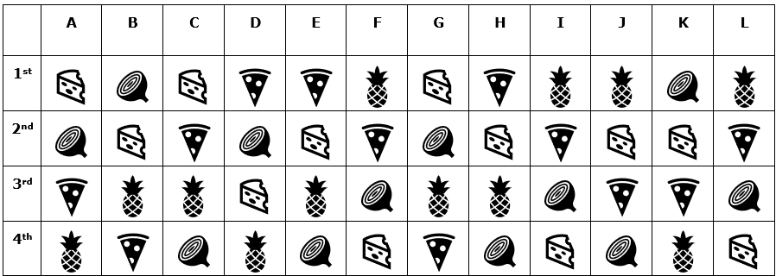

**The majority required to win is equal to half the number of voters, plus one. In this case, (12/2) + 1 = 7.**

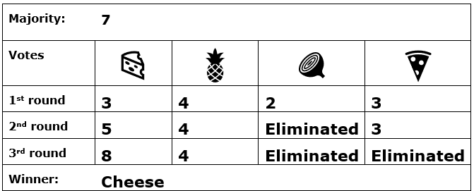

Given that no topping obtains a majority in the first round, students should eliminate the last placed topping which is Veggie and instead count its 2nd choice votes. In other words, they should act as if votes for Veggie are no longer in the table – see below.

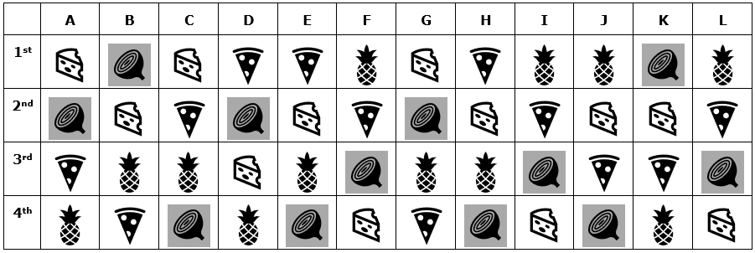

With the Veggie votes removed and redistributed, in the second round of voting there is still no topping which obtains a majority, so students should eliminate the topping with the fewest votes this round, which is now Pepperoni, and include its 2nd preference votes instead (or 3rd preference if veggie is it’s 2nd preference, as in the case of voter D).

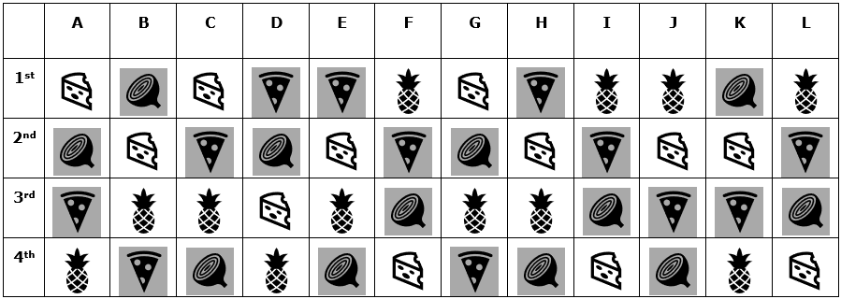

With the votes redistributed, Cheese now gets 9 votes, therefore reaching the majority of 7, and is the winner.

Extension questions:

Students need to begin by calculating the majority needed immediately, based on the number of votes actually cast.

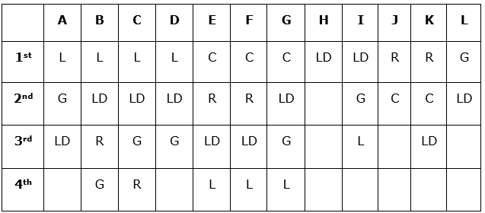

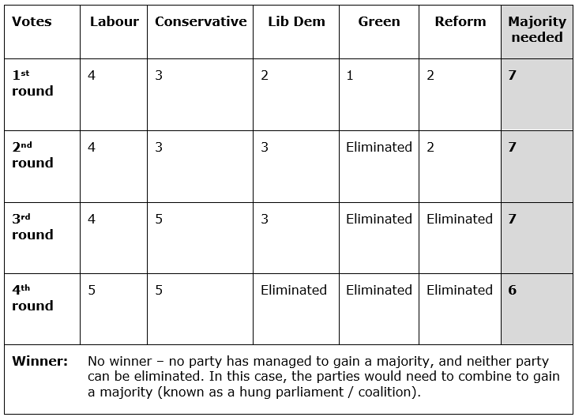

**Worked Solution:**

Given that no party obtains a majority, students should strike out the last placed party which is Green and re-distribute its votes.

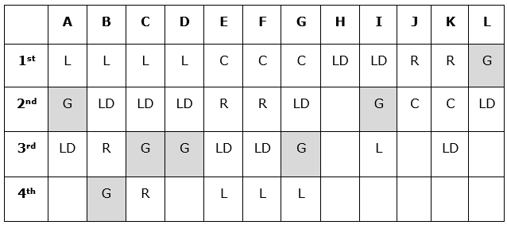

Again, no party obtains a majority, so students should strike out the last placed party which is now Reform and re-distribute its votes.

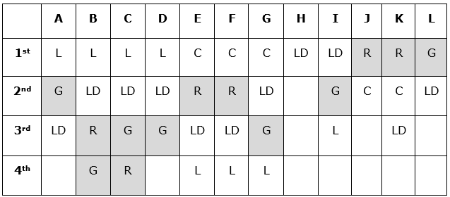

Now, even though Conservatives have the highest number of votes (5), there is still no majority (as 7 votes are still needed), so the party with the lowest number of votes, Lib Dems, are eliminated.

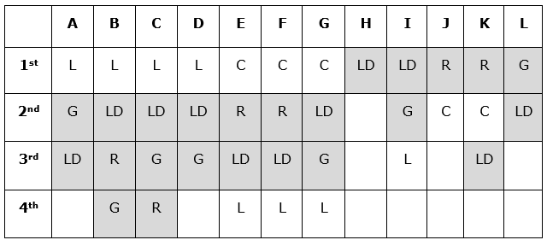

With Lib Dems eliminated, the total number of votes has now reduced by 2, as 2 of the voters have no remaining preferences. As such, the number of votes needed to reach majority must be calculated again: **(10/2) + 1 = 6 votes.**

Conservatives and Labour each have 5 votes – no party reaches majority.

**Worksheet 3: Borda**

Instead of just putting down their favourite pizzas (or their first preferences), each family member has ranked their preferences, based on the four toppings available. *These rankings are the same as for Worksheet 2 above.*

Start by determining how many points each of the preference gets. Once you know this, calculate the number of points each pizza topping gets and the one with the highest number is the winner.

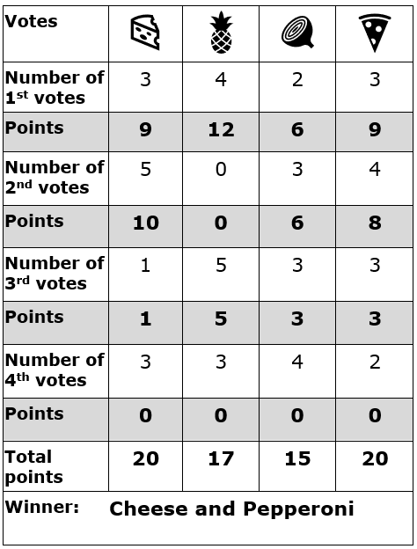Which pizza wins?

The formulae below should be used to calculate the number of points earned by each topping. **P = 4** (the total number of options)

**1st preference:** P-1 = 3

**2nd preference:** P-2 = 2

**3rd preference:** P-3= 1

**4th preference:** 0

Given that both cheese and Pepperoni have the same number of points, there is a tie.

Extension questions

Students may come up with many ways to break the tie, but some may include:

* Repeating the vote with only cheese and pepperoni as options
* Coin toss/draw straws
* Order whichever is cheapest

Anything that changes the number of points that cheese and/or pepperoni get, will change the winner. For example:

* Voter H has cheese in 1st and pepperoni in 2nd
* Voter B has pepperoni in 3rd and pineapple in 4th

There are also many ways that changing the point distribution will change the winner. As an example, massively increasing the weighting of the 1st preference can result in a pineapple win, as below:

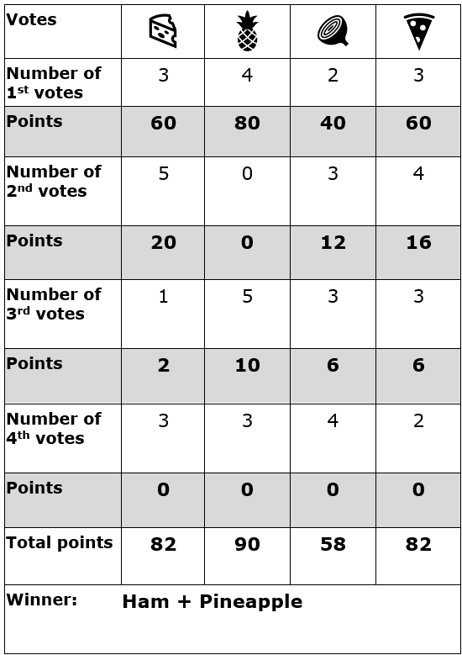**1st preference:** P x 5 = 20

**2nd preference:** P = 4

**3rd preference:** P / 2 = 2

**4th preference:** 0